Software Requirements Specification (SRS)
Project Name: E-Habitat: Interactive Server Room Monitoring Simulator
Client/Sponsor: Self-Proposed
Team Members:
Name | Role/Responsibilities | Email
Logan Caraballo | Project Lead / Backend | caraballol2@southernct.edu
Jared He | Frontend / UI | hej6@southernct.edu
Gavin Paeth | Data, Testing | paethg1@southernct.edu
Document Version: v1.1
Last Updated: 27 Feb 2026

1. Executive Summary

1.1 Project Overview
E-Habitat is an interactive educational simulation platform designed to help learners understand distributed systems concepts by comparing centralized and edge-based monitoring architectures in a realistic server room environment. The system simulates thermal, airflow, and humidity dynamics across multiple virtual nodes and visualizes how different monitoring strategies detect anomalies under identical conditions. E-Habitat enables hands-on exploration of architectural tradeoffs without requiring physical infrastructure.

1.2 Problem Statement
Students studying distributed systems often encounter abstract concepts such as edge computing, centralized monitoring, latency, and bandwidth tradeoffs without access to realistic experimentation environments. Existing tools are either production-grade monitoring systems that are too complex for educational use or purely theoretical materials that lack experiential learning. This gap limits students’ ability to develop intuition about real-world distributed system behavior. This is why our team must create a new product that bridges this gap, adding personalization to the learning process.

1.3 Solution Overview
E-Habitat addresses this gap by providing a controlled, visual, and interactive simulation where centralized and edge monitoring architectures operate simultaneously on the same environmental data. By allowing users to inject anomalies and observe detection latency, bandwidth usage, and system behavior in real time, the platform makes distributed systems principles concrete and observable.

1.4 Client Context
Client Organization: Self-Proposed
This project is self-proposed and intended for use by computer science students, instructors, and self-learners in academic settings. The primary success criteria are educational clarity, ease of setup, and the ability to demonstrate architectural tradeoffs during live demos or guided lab exercises. Requirements and scope were validated against typical distributed systems course objectives and instructor-led demonstration needs.

2. User Research & Personas

2.1 Research Methods
Research conducted:
- [ ] Client discovery interviews ([number] conducted)
- [ ] End-user interviews ([number] conducted)
- [ x ] Observation/shadowing
- [ ] Survey ([number] responses)
- [ ] Competitive analysis
- [ x ] Other: Course experience, review of distributed system curriculum, analysis of existing monitoring and simulation tools.
Key Findings:
1. Visual feedback is a top priority for knowledge retention
2. Experiments must be repeatable
3. Interface must be simple and approachable to ensure a focus on architectural behavior rather than operational complexity.

2.2 User Personas

Primary User Persona
Name & Role: John Doe, Computer Science Student
Demographics: Upper-level undergraduate or graduate student studying distributed systems and/or related topics. Intermediate technical proficiency.
Organization Context: School of around ~10,000 students, student, reporting to their professor(s)
Needs:
- Observe how centralized and edge monitoring differ under the same conditions
- Experiment with anomalies and interpret system behavior
Pain Points:
- Abstract concepts without hands-on reinforcement
- Lack of accessible simulation tools
Goals:
- Develop intuition about latency and bandwidth
- Learn how to handle faults and anomalies in the system
Technology Context: Laptop running a local development environment

Secondary User Persona
Name & Role: Jane Doe, Course Instructor
Demographics: University-level instructor teaching systems courses
Needs:
- Reliable classroom demonstrations
- Controlled scenarios to illustrate specific concepts
Pain Points:
- Contemporary software is too complicated to efficiently convey intended concepts
Goals:
- Reinforce lecture material with visual, repeatable experiments
Add additional personas if your application serves distinctly different user types.

3. User Stories

Format
As a [type of user], I want [some goal] so that [some benefit].

Must Have (MVP Features)
These are the features required for your application to deliver core value. Aim for 8-12 user stories.

Authentication & User Management
US001: As a new user, I want to create an account so that I can access the system securely.
Acceptance Criteria:
- [ x ] User can register with email/password
- [ x ] Validation requirement - email must be the proper format
- [ ] Security requirement - e.g., password meets complexity rules
- [ ] Post-registration behavior - e.g., confirmation email sent
- [ x ] Redirect behavior - e.g., user redirected to dashboard
US002: As a returning user, I want to log in and stay authenticated so that I don't have to re-enter credentials frequently.
Acceptance Criteria:
- [ ] User can log in with [method]
- [ x ] Session persists until manual logout
- [ x ] User can manually log out
- [ ] Session expires after [duration] of inactivity

Core Feature: Simulation Control
US003: As a user, I want to start and stop a simulation so that I can observe environmental behavior in real time.
Acceptance Criteria:
- Telemetry begins streaming within one second of start
- Simulation runs at one-second time steps
- Real-time updates
- Alerts update user to notable simulation events
US004: As a user, I want to configure baseline environmental parameters so that I can explore different operating conditions.
Acceptance Criteria:
- Users can set temperature, airflow, and humidity ranges before simulation start
- Invalid values are rejected with clear feedback
- Parameters can be adjusted in real-time by the user

Core Feature: Anomaly Interaction
US005: As a user, I want to inject predefined anomaly scenarios so that I can observe how each architecture responds.
Acceptance Criteria:
- Thermal spike and HVAC failure scenarios are supported
- Visual indicators show when anomalies occur
- Anomaly alerts will show up in a well-defined area

Core Feature: Architecture Comparison
US006: As a user, I want to view centralized and edge monitoring results side by side so that I can compare tradeoffs.
Acceptance Criteria:
- Both architectures run simultaneously on identical data
- Comparison metrics include detection latency and message volume
- Support for up to 3 nodes running simultaneously in a side-by-side view

Core Feature: Visualization
US007: As a user, I want to view real-time telemetry and alerts so that I can interpret system behavior.
Acceptance Criteria:
- Live charts update with less than 200ms latency
- Alerts appear when anomalies are detected
- Visual aids such as gauges and sliders for accessibility

Should Have (Post-MVP Enhancements)
Features to implement if time permits after MVP is complete.
- User accounts and authentication (tentative)
- Saved simulations and templates (tentative)
- Multi-user classroom support
- Advanced anomaly models

Could Have (Future Considerations)
Features documented for future development, not planned for this semester.
USXXX: [Nice-to-have feature]
- [Brief description]

4. Features & Requirements

4.1 Core Features
- Simulation Engine — Simulates thermal, airflow, and humidity dynamics across three virtual nodes at one-second intervals.
- Dual Monitoring Architectures — Centralized raw-telemetry streaming and edge-based local anomaly detection running concurrently.
- Anomaly Scenarios — Two predefined anomaly scenarios with manual injection controls.
- Real-Time Dashboard — Displays telemetry, alerts, and architecture comparison metrics.
- Educational Comparison Metrics — Detection latency and network message volume for each architecture.
Aim for 5-8 core features. Each should map to multiple user stories.

4.2 Technical Requirements

Authentication & Authorization
- Authentication method - email/password
- User profile creation and management
- Session management (persists until user logs out)
- Role-based access for students, instructors
- Password reset and account recovery

Data Management (CRUD Operations)
- Create: Users can create nodes with preset configurations
- Read: Users can see node behavior react to changing environmental parameters
- Update: Users can modify parameters in presets and active simulations
- Delete: Users can delete unwanted presets

Database & Storage
- Primary Database: SQLite
- Key Data Entities: User accounts, user-created node presets
- Users: User authentication details, roles
- User Accounts: User’s email and password
- User Presets: User’s previously created node presets

Simulation Engine
- The system shall simulate at least three virtual nodes concurrently.
- The system shall stream telemetry using WebSockets.
- The system shall compute anomaly scores using a pre-trained Isolation Forest model.
- The system shall display alerts when anomaly thresholds are exceeded.

4.3 Non-Functional Requirements

Performance
- Dashboard updates shall occur with less than 200ms latency
- Support for at least three nodes without dropped messages

Security
- HTTPS encryption for all data transmission
- Hashed passwords with industry-standard encryption
- Input validation

Usability
- Interface shall support live demos without prior configuration
- Core actions shall be accessible within two clicks
- UI elements should be intentionally placed with simplicity in mind
- Optimization for dark mode theme
- All core information should be available at-a-glance

Reliability
- System shall run continuously for at least one hour without failure
- Error messages should be used when appropriate
- ML engine should avoid hallucinations

5. System Design

5.1 Technology Stack
Frontend:
- Languages: TypeScript (typed superset of JavaScript)
- Framework: Next.js, React
- UI Library: Tailwind CSS, Material UI
Backend:
- Runtime: Python 3.10+, Uvicorn (runtime server)
- Framework: FastAPI
- Authentication Library: Planned
- Validation Library: Pydantic (built into FastAPI)
Database:
- Database: SQLite (planned)
- ODM/ORM: Planned
Deployment:
- Hosting Platform: Local
- Process Manager: Local
- Web Server: Nginx (planned)
- SSL Certificate Source: Let’s Encrypt (planned)
Development Tools:
- Version control: Git + GitHub
- Package Manager: npm, pip
- Environment Management: Node.js runtime, Python virtual environment (venv)
- Testing Tools: pytest
Third-Party Services:
- Authentication Provider: None
- Email Services: None
- Other: NumPy (library in Python for ML integration)

5.2 User Interface Design
Design Principles:
- Desktop-first responsive design
- Minimal clicks to perform core functions
- “At-a-glance” viewing convenience
Key Screens:
1. Landing/Login Page
- Purpose: Provide users with the option to login
- Key Elements: Primary dashboard, login as button in header
- User Actions: Dashboard to perform primary functions, option to login
2. Dashboard
- Purpose: All functionality intentionally laid out for user convenience
- Key Elements: Nodes, visual aids, sliders (for configurable parameters), alerts feed, status aids
- User Actions: Adjust parameters, view effects in real-time
3. [Core Feature Screen]
- Purpose: [Description]
- Key Elements: [List main UI components]
- User Actions: [What users can do]
4. [Core Feature Screen]
- Purpose: [Description]
- Key Elements: [List main UI components]
- User Actions: [What users can do]
5. Profile/Settings
- Purpose: User account management
- Key Elements: View previously saved presets, change email for login
- User Actions: View presets, change login information, logout
Include wireframes or mockups: Attach hand-drawn sketches, Figma designs, or other visual representations of key screens.
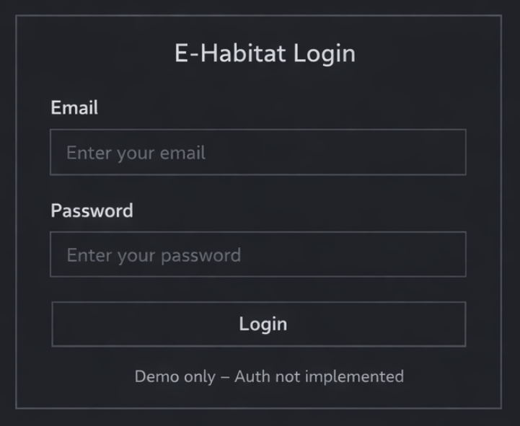
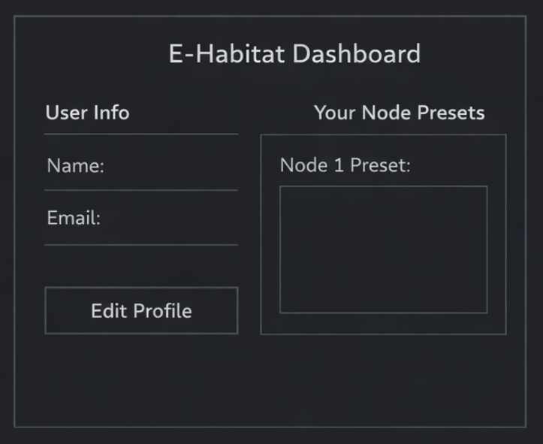
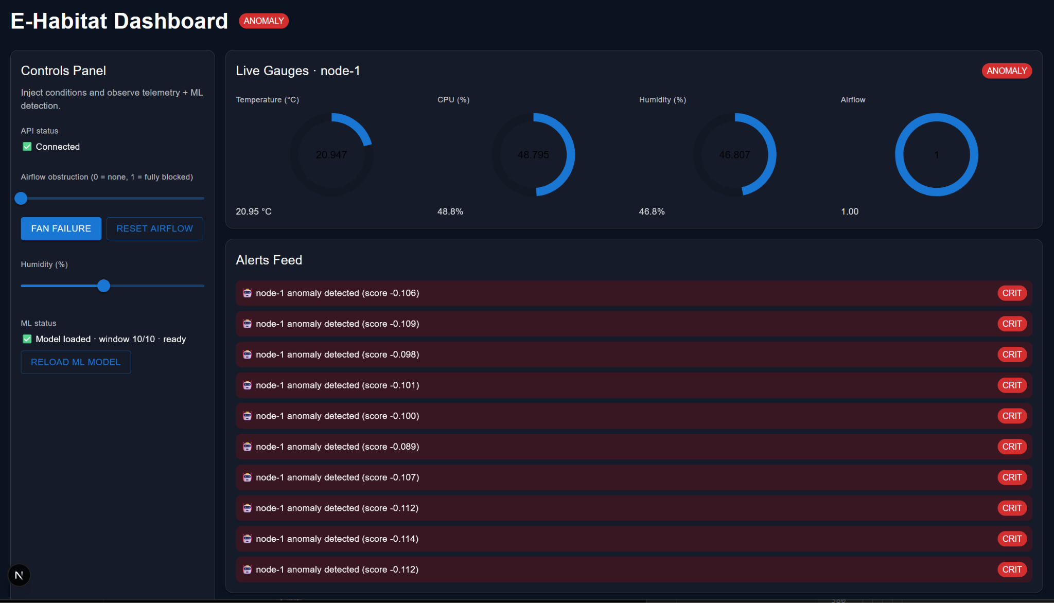
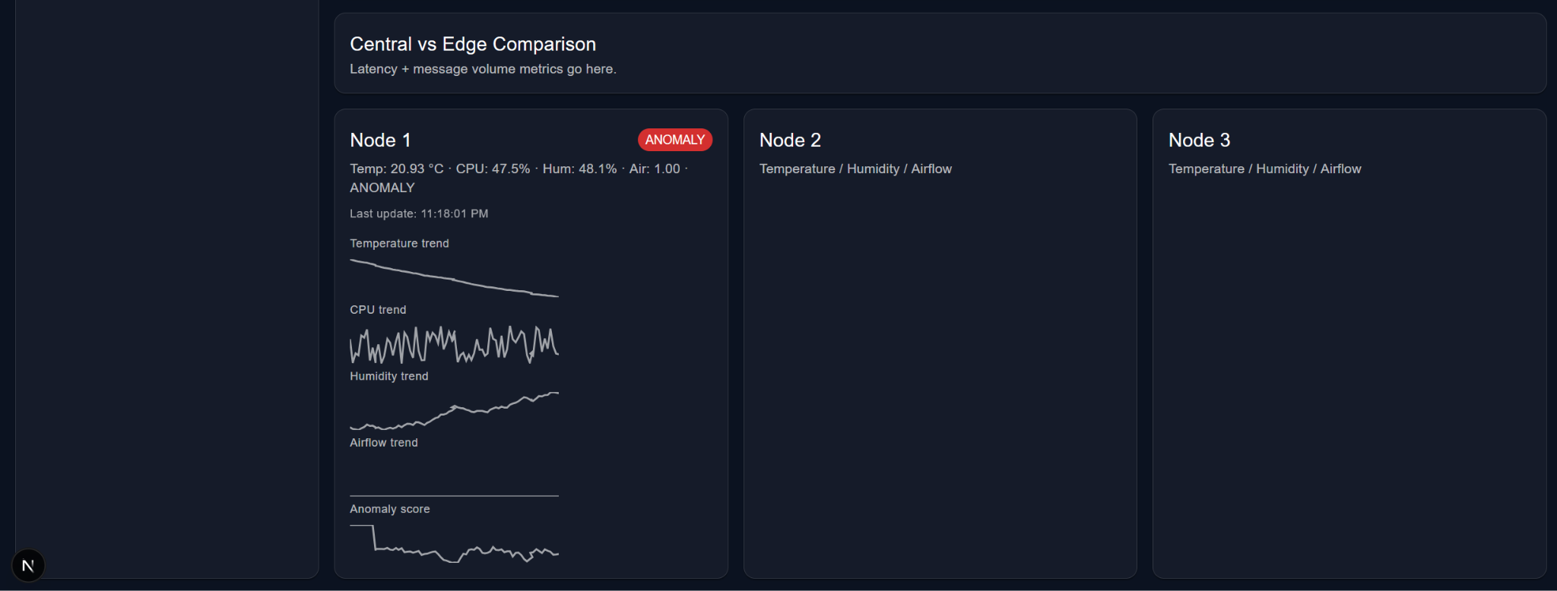

5.3 Database Schema
Entity Relationship Diagram: [Attach ERD or describe relationships]
Entity: User
{
_id: ObjectId,
email: String (unique, required),
passwordHash: String (required), // or googleId for OAuth
firstName: String (required),
lastName: String (required),
role: String (enum: ['admin', 'coordinator', 'user']),
profilePicture: String (URL, optional),
createdAt: Date,
lastLogin: Date,
isActive: Boolean (default: true)
}
Entity: [Your Main Entity]
{
_id: ObjectId,
[field]: [type] (constraints),
[field]: [type] (constraints),
[field]: [type] (constraints),
createdBy: ObjectId (ref: User, required),
createdAt: Date,
updatedAt: Date
}
Entity: [Your Second Entity]
{
_id: ObjectId,
[field]: [type] (constraints),
[relationship]: ObjectId (ref: [Entity], required),
createdAt: Date
}
Include all main entities with field names, types, constraints (required, unique, enum values), relationships (references), and indexes for performance.

5.4 System Architecture
Architecture Pattern: REST client-server (currently), MVC (planned)
Component Diagram:
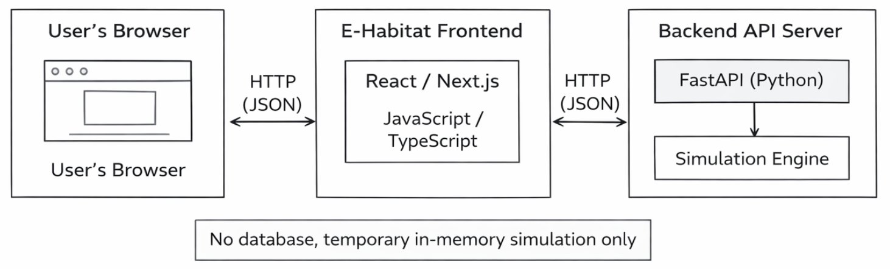
Request/Response Flow:
1. User makes HTTP GET request (browser/client)
2. FastAPI (route handler) calls node.step() to advance one timestep
3. Simulation Engine updates state in memory (various user-configurable parameters)
4. FastAPI returns JSON response, UI state updates
Security Layer:
- Authentication Handling: Planned
- Authentication Enforcement: Planned
- Input Validation: Planned

6. Implementation Plan

6.1 Development Phases

Phase 1: Foundation & Setup
Timeline: Week 0 - Week 4
Goal: Project setup, authentication working, basic deployment
Deliverables:
- [ x ] Development environment configured (all team members)
- [ x ] GitHub repository with branching strategy
- [ x ] Extract normal operating ranges from all three datasets
- [ x ] Calculate statistical distributions (mean, variance, percentiles)
- [ x ] Set simulation default parameters to match real-world baselines
- [ ] Application deployed to hosting platform
Team Responsibilities:
- Logan: Initialize nodes, parameter effects on node behavior
- Jared: Nodes displayed on page, parameters affect node simulation
- Gavin: Process datasets, establish baseline statistics

Phase 2: Core Feature Development
Timeline: Week 5 - Week 8
Goal: Primary features functional
User Stories Targeted:
- US003: Simulation start/stop
- US004: Environmental parameters adjustable by user
- US005: Anomaly injection
- US006: Node comparison
Deliverables:
- [ x ] Run simulation with real-world parameters
- [ x ] Compare synthetic output distributions to real data
- [ x ] Tune heat transfer coefficients, cooling rates, and noise levels
- [ x ] Basic UI for primary workflows
- [ x ] Generate 48 hours of synthetic normal operation telemetry
- [ x ] Combine with normal periods extracted from real datasets
- [ x ] Train Isolation Forest on merged normal data
- [ x ] Validate detection on known anomalies from real datasets
Team Responsibilities:
- Logan: Implement additional parameters, ML initialization
- Jared: Reflect additional parameters on dashboard, addition of alerts feed, ML integration
- Gavin: Establish dataset baseline for ML model, database initialization

Phase 3: Feature Completion & Integration
Timeline: Week 9 - Week 12
Goal: All MVP features complete
User Stories Targeted:
- US001-US007: All must-have features implemented
- Integration between components
- Error handling and edge cases
Deliverables:
- [ ] All core features complete and integrated
- [ ] Comprehensive error handling
- [ ] UI/UX refinements based on testing
- [ ] Client feedback incorporated
- [ ] Performance optimization
Team Responsibilities:
- Logan: Physics engine refinement, ML training continued
- Jared: Integration of additional UI elements, additional ML requirements
- Gavin: Database integration for users, user-configurable presets

Phase 4: Testing, Polish & Documentation
Timeline: Week 13 - Week 16
Goal: Production-ready application with full documentation
Deliverables:
- [ ] User acceptance testing with client
- [ ] Bug fixes and refinements
- [ ] Accessibility compliance testing
- [ ] Security review
- [ ] Performance optimization
- [ ] User documentation (help guides, FAQ)
- [ ] Technical documentation (README, deployment guide)
- [ ] Fully tested, production-ready application
- [ ] Client sign-off

Phase 1: Foundation (Weeks 1–4) — COMPLETE
Goal: Working single-node simulation with physics engine, ML pipeline, and basic dashboard.

Completed Deliverables
- Development environment and GitHub repository configured for all team members.
- Physics engine fully implemented: thermal, airflow, and humidity models.
- Real datasets (MIT Intel Lab, DOE, Kaggle HVAC) downloaded and processed; statistical summaries extracted.
- Physics parameters calibrated against real-world data distributions.
- Single virtual node prototype implemented with anomaly detection hooks.
- Isolation Forest model trained on synthetic calibrated telemetry and serialized as .pkl.
- FastAPI REST backend established with /telemetry/step endpoint.
- Next.js dashboard displaying live telemetry with sub-200ms update latency.
- Thermal spike anomaly injection implemented and verified end-to-end.
Sprint 1 Deliverable: Achieved. Single-node simulation streaming telemetry, detecting injected thermal anomaly, and displaying on dashboard.

Phase 2: Multi-Node & Architecture Comparison (Weeks 5–8) — PARTIALLY COMPLETE
Goal: 3-node system with both monitoring architectures operational and comparison metrics visible.

Completed Deliverables
- HVAC failure anomaly scenario implemented in the physics engine.
- Architecture comparison panel added to dashboard (detection latency, message volume).
- Backend alert routing and aggregation logic implemented.
- Dashboard UI expanded for multi-node telemetry panels.
- Performance optimization: chart history capped at 5 minutes, updates throttled to 1–2 per second.
- README drafted with setup instructions, architecture diagram, and usage guide.

In Progress / Delayed
- WebSocket streaming: currently implemented as REST polling (/telemetry/step). Migration to persistent WebSocket connection is the top Phase 3 priority.
- Multi-node backend: api.py initializes one VirtualNode instance. Three-node multiplexing targeted for Phase 3 Week 9.
- SQLite database: system operates in-memory. Schema design and implementation delayed to Phase 3.
- Authentication: no auth logic present in current codebase. Targeted for Phase 3 Weeks 10–11.
Sprint 2 Deliverable: Partially achieved. Architecture comparison panel is operational. Full 3-node WebSocket demo deferred to Phase 3.

Phase 3: Core Completion & Infrastructure (Weeks 9–12)
Goal: Close all Must Have gaps (WebSockets, 3 nodes, authentication, SQLite). Complete and test all MVP user stories.

Week 9 — Infrastructure Sprint
- Logan: Migrate /telemetry/step REST endpoint to persistent WebSocket connection. Update message schema to preserve node identity across multiplexed streams.
- Logan: Expand backend to initialize and run three VirtualNode instances concurrently. Validate synchronization and consistent timing.
- Gavin: Design and implement SQLite schema for user accounts and node presets. Initialize database layer with migration scripts.
- Jared: Update frontend WebSocket client to handle multi-node streams. Confirm dashboard renders all three node panels simultaneously.

Week 10 — Authentication & Presets
- Logan: Implement email/password authentication endpoints (register, login, logout). Add session middleware to FastAPI.
- Gavin: Implement CRUD operations for node presets backed by SQLite. Connect preset management to user session.
- Jared: Build login/register UI screens. Integrate session persistence and protected routes into Next.js frontend. Add preset management to profile/settings screen.

Week 11 — Third Anomaly Scenario & Integration Testing
- Logan: Implement a third anomaly scenario (airflow blockage) if timeline permits. Confirm cascading physics effects across nodes.
- All: Full system integration testing under 3-node load. Address race conditions, timing issues, or UI lag identified during testing.
- All: End-to-end 60-minute continuous runtime validation.

Week 12 — Phase 3 Stabilization
- All: Bug fixes from integration testing.
- Jared: Dashboard UI refinements based on internal review — layout clarity, labeling, and educational cues.
- All: Documentation updates — README, API reference, architecture diagrams.
Phase 3 Deliverable: All Must Have user stories (US001–US007) fully implemented and integration-tested. Three-node WebSocket simulation with authentication and SQLite persistence operational.

Phase 4: Testing, Polish & Finalization (Weeks 13–16)
Goal: Production-ready demo system with comprehensive testing, external user validation, and complete documentation.

Week 13 — External User Testing
- Recruit 2–3 external testers (classmates not on the team).
- Conduct observed usability sessions: install, run simulation, inject anomaly, interpret metrics.
- Document usability issues, confusion points, and documentation gaps.
- Prioritize fix list from tester feedback.

Week 14 — Feedback Integration & Security Review
- All: Address high-priority usability issues from Week 13 testing.
- Logan: Security review — authentication flow, input validation, session handling.
- Gavin: Finalize unit test suite for physics engine and anomaly detection. Achieve meaningful coverage on all critical paths.
- Jared: Accessibility review — keyboard navigation, contrast, label clarity.
- All: Documentation improvements based on tester feedback.

Week 15 — Demo Preparation & Final Testing
- All: Final integration testing under demo conditions. Confirm zero crashes and consistent anomaly detection across all scenarios.
- All: Demo rehearsal — script complete demonstration sequence highlighting architectural tradeoffs and performance metrics.
- All: Prepare presentation materials: slides covering system design, validation process, tradeoffs observed, and lessons learned.
- All: Code cleanup — remove dead code, verify docstrings and comments are complete, finalize repository structure.

Week 16 — Final Demo & Submission
- Deliver live demonstration showing anomaly injection and architecture comparison in real time.
- Submit final SRS, source code, documentation, and presentation materials.
- Post-mortem review: document lessons learned and future enhancement roadmap.
Phase 4 Deliverable: Complete, tested, documented system demonstrated live. All success criteria met. Repository in final submission state.

6.2 Anomaly Detection Pipeline (Replaced Client Engagement Schedule)
Training (Offline):
- Generate baseline telemetry using physics engine with real-data parameters
- Extract sliding-window features (10-second windows)
- Train Isolation Forest on normal operation only
- Save model as .pkl artifact for deployment
Inference (Real-Time During Simulation):
- Nodes collect telemetry in sliding windows
- Extract features (mean, variance, rate-of-change)
- Run Isolation Forest prediction
- If anomaly score exceeds threshold → trigger alert
- Transmit alert (edge) or raw data (centralized) to backend
Why Isolation Forest:
- Unsupervised: doesn't require labeled anomalies
- Fast: suitable for real-time edge inference
- Interpretable: anomaly scores are understandable
- Proven: widely used in production anomaly detection
Limitations Acknowledged:
- Detects deviations, doesn't predict future events
- Threshold tuning required for different scenarios
- May produce false positives on rare-but-normal events
- More sophisticated models (LSTM, Autoencoder) deferred to post-capstone

6.3 Testing Strategy
Testing Approaches:
- Manual Testing
- Test all user workflows before each milestone
- Cross-browser testing (Chrome, Firefox, Safari, Edge)
- Mobile responsiveness testing
- Client-specific scenario testing
- User Acceptance Testing (UAT)
- Testing sessions using external systems and/or users (if possible) in Weeks 13-15
- Document feedback and prioritize fixes
- Security Testing
- Authentication flow testing
- Authorization/access control verification
- Input validation testing
Success Criteria:
- [ ] All must-have user stories meet acceptance criteria
- [ ] No critical bugs in core workflows
- [ ] Performance meets non-functional requirements
- [ ] Client approves final product

6.4 Deployment Strategy
Environments:
- Development: Local machines, test database
- Production: Google Cloud Platform (if credits are granted), production database
Deployment Process:
1. Development: Code and test locally
2. Version control: Commit to feature branch
3. Code review: Pull request and team review
4. Merge: To main branch after approval
5. Deploy: GCP deployment SOP
6. Verify: Test production deployment
Rollback Plan:
- Keep previous version tagged in Git
- Database backup before each deployment
- Rollback procedure documented

7. Risk Assessment

Technical Risks
Risk 1: Physics Engine Complexity Exceeds Timeline
- Impact: High - Core simulation doesn't work realistically, undermines entire project
- Likelihood: Medium
- Mitigation:
- Start with simplified thermal-only model in Week 1
- Validate against real data early (Week 2)
- If complex physics takes >3 weeks, simplify models using lookup tables instead of differentials
- Contingency: Use temperature only; defer humidity/airflow to post-capstone
Risk 2: WebSocket Performance Issues at Scale
- Impact: Low - Dashboard lags or drops messages with multiple nodes
- Likelihood: Medium
- Mitigation:
- Test with 3 nodes early (Week 5)
- Implement message batching if needed
- Use existing WebSocket libraries (avoid custom protocols)
- Contingency: Reduce to 2 nodes for demo, or use HTTP polling instead of WebSockets
Risk 3: Real-Time Dashboard Responsiveness
- Impact: Low - Charts stutter, poor user experience
- Likelihood: Medium
- Mitigation:
- Use proven charting library (Recharts) optimized for real-time
- Limit chart history to last 5 minutes
- Throttle updates to 1-2 per second
- Contingency: Dashboard shows delayed data (5-10 second lag acceptable), or snapshot updates
Risk 4: SQLite Performance for Time-Series Data
- Impact: Medium - Query slowdowns, storage bottlenecks
- Likelihood: Low
- Mitigation:
- Keep simulation duration short (<1 hour)
- Index timestamp columns
- Batch inserts
- Contingency: Write-only database during simulation, or switch to in-memory storage
Risk 5: Integration Challenges Between Components
- Impact: High - Components work separately but fail together
- Likelihood: Low
- Mitigation:
- Integration testing starting Week 4, frequent end-to-end testing
- Contingency: Simplify interfaces, use polling instead of real-time where needed
Risk 6: Anomaly Detection Produces Too Many False Positives
- Impact: High - Demo shows useless alerts, undermines educational value
- Likelihood: Low
- Mitigation:
- Tune Isolation Forest threshold during validation (Week 4)
- Contingency: Use simple rule-based detection (threshold crossings) instead of ML

Project Risks
Risk 1: Scope creep - initial plans exceed timeline
Impact: High
Likelihood: Medium
Mitigation:
- Document clear scope in SRS with client sign-off
- Use "Should Have" and "Could Have" for stretch features
- Weekly communication about progress vs. Scope
- Document future enhancements for post-semester
Risk 2: Team member availability
Impact: Medium - Work falls behind schedule
Likelihood: High
Mitigation:
- Clear task assignments with deadlines
- Weekly standups/meetings
- Parallel workstreams, cross-training different components
Risk 3: Lack of funds
Impact: High - Will not be able to host on GCP VM without credits, forced local operations
Likelihood: High
Mitigation:
- Winning the lottery
- Finding large suitcase of money on side of road (or elsewhere)
- Otherwise sudden influx of cash

8. Success Metrics

User Metrics
- Metric: User can view all relevant data at-a-glance
- Target: 80% of users report adequate information presented on dashboard; <10% users complain about excessive visual clutter. <1% users complain about lack of information
- Measurement: Blind test with unsuspecting users (no chance for bias)

Technical Metrics
- Simulation load time: <10 seconds
- Uptime during testing: >60 minutes with no crash
- Zero critical security vulnerabilities
- Anomalies detected in both architectures during demos
- 2-3 configurable anomalies

Client Success Criteria
Document specific success criteria defined with your client:
- [e.g., "System reduces admin time by 50% vs. current process"]
- [e.g., "100% of volunteer hours tracked accurately"]
- [e.g., "Generate compliance reports in under 5 minutes"]

Team Metrics
- All phase milestones completed on schedule
- All team members contribute to codebase
- Client attends and approves major presentations

Documentation:
- Comprehensive README (setup, usage, architecture)
- User guide with tutorial scenarios
- Technical documentation (API, data models, physics equations)
- Architecture diagrams and system flow
- Installation requirements (.txt) in directory for easy installation

Code Repository:
- Clean, well-organized GitHub repository
- Unit and integration test suite
- Setup scripts for easy installation
- Example configurations and data

Final Presentation:
- Live demo of core use cases
- Discussion of architectural tradeoffs observed
- Lessons learned and future directions

9. Appendix

A. Glossary
Define technical terms, acronyms, and domain-specific terminology:
- ML: Machine Learning - Process of training algorithms to make predictions and/or decisions based on learned data and pattern recognition.
- ORM/ODM: Object-Relational/Document Mapping - Allows for interaction with a relational database using objects in a programming language (instead of raw SQL queries)
- MVP: Minimum Viable Product - core features needed for launch
- CRUD: Create, Read, Update, Delete - basic database operations
- UAT: User Acceptance Testing - testing with real users
- WebSocket: A persistent, full-duplex communication protocol enabling real-time data streaming between client and server.
- Isolation Forest: An unsupervised machine learning algorithm for anomaly detection based on random partitioning of feature space.
- Centralized Computing: A centralized architecture where data processing occurs in one central location (usually a cloud data center).
- Edge Computing: A distributed architecture where data processing occurs locally at or near the data source, rather than in a central server.

B. References
- [Client documentation or requirements]
- [User research artifacts]
- [Technical documentation consulted]
- [Third-party API documentation]

C. Change Log
Date | Version | Changes | Author
01 Feb 2026 | v1.0 | MVP SRS draft | Logan, Jared, Gavin
27 Feb 2026 | v1.1 | SRS modified according to professor’s comments | Logan,  Jared,  Gavin
01 Mar 2026 | v1.2 | Corrected project timeline to 16 weeks (4 phases); expanded Phases 3 and 4 with full week-by-week detail; updated Sprint 3 deliverable; added Phase 4 Testing & Finalization section; minor scope clarifications throughout | Logan, Jared, Gavin
[Date] | v2.0 | Final SRS after presentation feedback | [Team]

Document Status
Current Status: Draft / Under Review / Approved
Approval:
- [ x ] Team approval (all members reviewed)
- [ x ] Client approval (requirements confirmed)
- [ x ] Instructor feedback incorporated

Prepared by: Logan, Jared, Gavin
Course: CSC400 - Computer Science Project Seminar
Semester: Spring 2026

